

**Faculty of Computing**

**Development of Enterprise Application I**

**Group Assignment**

|  |  |  |  |  |
| --- | --- | --- | --- | --- |
| **INDEX NUMBER** | | **STUDENT NAME** | | |
| **22841** | | **U. B. M. H. E. M. Balasuriya** | | |
| **22702** | | **C. M. D. N. Seneviratne** | | |
| **23686** | | **S. T. Kumasaru** | | |
| **22706** | | **A. S. Hendavitharana** | | |
| **22819** | | **C. R. Wedage** | | |
|  | |  | | |
| **YEAR OF STUDY AND SEMESTER** | | **YEAR 2 SEMESTER 1** | | |
| **MODULE CODE** | **SE204.3** | | **MODULE NAME** | **Development Of Enterprise Application I** |
| **MODULE LECTURER** | **Mr. Chaminda Wijesinghe** | | **SUBMISSION DATE** | **2022.10.08** |
| **Declaration:** I certify that I have not plagiarized the work of others or participated in unauthorized collusion when preparing this assignment.  **Signature of the Group Leader: Date: 2022.10.08** | | | | |
| **For office purpose only:** | | | | |
| **GRADE / MARK** |  | | | |
| **COMMENTS** |  | | | |



**Pheonix Airlines PVT Ltd.**

Flights Reservation Platform



**CONTENT**

1. Introduction
2. Enterprise Application Structure
3. Description about each page

3.1. Home Page

3.2. Admin

3.3. Staff

3.4. User

3.5. Login Page

4. Conclusion

5. Our Directory

1. **INTRODUCTION**



According to the given scenario we’ve created a flight reservation platform which is known as Phoenix Airlines PVT Ltd.

This platform is especially designed for three main user categories,

* Admin Users,
* Staff Users,
* Regular Users.

From this platform, people who need to reserve flights can search for the relevant flights and their information as well. Then if they are comfortable with the time periods and the flights which are displaying, they can reserve them. According to the given scenario there should be two types of Staff groups, Group 01 & Group 02. Staff members can update or delete the flight details. And also staff members can add new flights as well. We’ve created a similar platform to the staff users but the features are vary according to the mentioned scenario. Admin users will be able to monitor all the activities of the Staff members and the users.

We’ve designed this platform where the users could get a better user expeience throughout their browsing period. Otherwise, if the users are not satisfied with their experience they will not use further our application.

We’ve thought to displaying some relevant information as a summary to the admin as well as the staff, because then they will be able to easily manage the useres and the applications. Even though they are from the system’s side we have to make a better experience for them as well because then the workload will be reduced as well as they can perform the tasks more efficiently.

1. **ENTERPRISE APPLICATION STRUCTURE**

Our enterprise application currently contains following main pages.

* Home
* Admin - Dashboards, Profile
* Staff - Dashboards, Chats, Profile etc.
* User - Dashboards, Chats, Profile etc.
* Login Page

Pages with special features

* Enable chat feature between staff and user
* Search and filter the flights as the user’s requirement
* User account management (for staff)
* Insights (for admin)

Site Integrations

* Maria DB Server
* JSP and Servlets
* Social Media Buttons
* Git-Hub Repository

**3. DESCRIPTION ABOUT EACH PAGE**

**3.1. HOME**

This is the first visible content of our enterprise application.

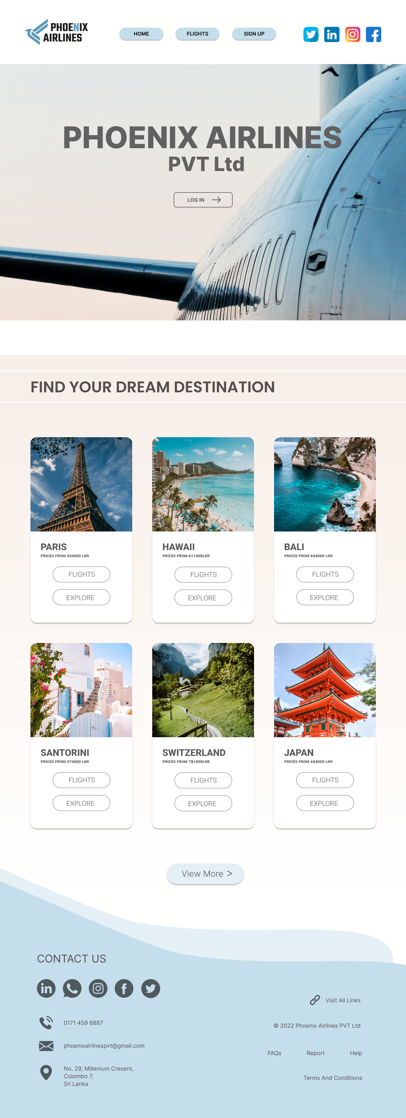

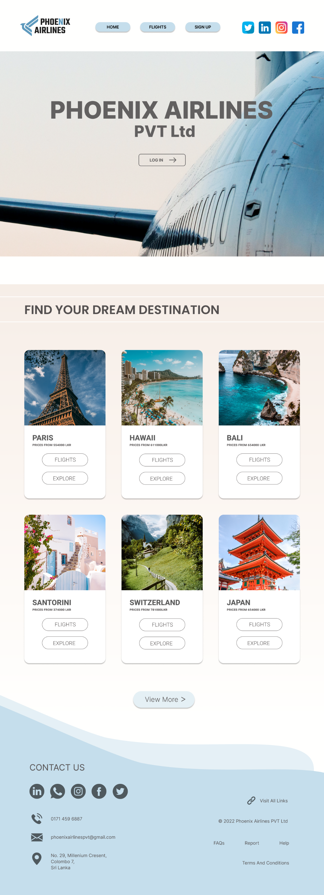

* 1. **ADMIN**

According to the given scenario, admin is the one who can see and monitor all the activities of the users and staff members. Admin have the authority to manage and access all the features in the application because the total control of the application is given to him.

For admin, we’ve created two special pages such as Dashboard and Insights. The features and the tasks which are assigned to those three pages will be described as follows.

* **Admin’s Dashboard**

In Admin Dashboard, we’ve thought to display the daily update about flight reservation because then admin doesn’t need to navigate here and there to see the summary of each day. From there we have displayed the no of departured flights and no of flights which are fully reserved and available to be reserved.

From that admin can be easily figure out the no of remaining seats for the passengers. By knwoing that information either he could reserve the flights for users or declined the request of reservation.

And also we’ve displayed the overall activities in the dashboard. From that admin could see the approved accounts and pending approvals daily. Then he could manage them effieciently. Otherwise admin may not have idea if there a lot of accounts which seek for the approvals or there isn’t any.

We’ve created some special features to monitor the deleted and recently added flights as well as handled user accounts.

From the Dashboard admin can update or undo the information, personalize, access advanced settings and FAQs, and also troubleshoot.

* **Insights**

From the insights admin can view a summary of the activities done by users and staff members. Admin will be able to that, who have deleted this flight details and who have added these details etc.

As well as recently reserved ticket details of the users and the information of those users will be displayed in this relavent page. And admin will see the total tickets which have been reserved in each day and specially the total income of the day at that particlular moment.

We’ve added those features for manage the admin’s workload easier and efficiently.

* 1. **STAFF**

According to the given functions in the description there should be two types of staff members in this application which is known as Group 01 and Group 02. Group 01 staff members can access some advanced functions than the Group 02 staff members. But we have created a similar pages to both two of the groups and they can select their particular group. Then the features which are relevant to those groups will be displayed. We have created five main pages for staff members such as Dashboard, Profile, Flights, User Account Management and Chats.

* Staff Dashboard

From the dashboard, staff members can see the details about the today’s flights and also they can reply to the user chats as well. Specially staff members can search for users accounts through their dashboards.

Staff members can navigate here and there through the buttons which we have created in the dashboard such as Chats, Settings, User Account Management, and FAQs etc.